University of Engineering and Technology, Taxila



DIP LAB # 14

Submitted BY:

Muhammad Fahad Khan (23-SE-64)

Submitted To:
Ma’am Nazia

Example 1:
import numpy as np

def lzw_compress(data):

dictionary = {bytes([i]): i for i in range(256)}

w = b""

compressed = []

dict_size = 256

for byte in data:

wc = w + bytes([byte])

if wc in dictionary:
w = wc

else:
compressed.append(dictionary[w])

dictionary[wc] = dict_size

dict_size += 1

w = bytes([byte])

if w:
compressed.append(dictionary[w])

return compressed

data = np.array(
[45, 45, 45, 45, 23, 23, 45, 45],
dtype=np.uint8
)

compressed = lzw_compress(data)

print(compressed)
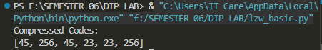

Example 2
import numpy as np
from PIL import Image
import matplotlib.pyplot as plt

img = Image.open("image.jpg").convert('L')

img_array = np.array(img)

bit_planes = []

for i in range(8):

plane = (img_array >> i) & 1

bit_planes.append(plane * 255)

fig, axs = plt.subplots(2, 5)

axs = axs.ravel()

axs[0].imshow(img_array, cmap='gray')

axs[0].set_title("Original")

for i, plane in enumerate(bit_planes[::-1]):

axs[i + 1].imshow(plane, cmap='gray')

axs[i + 1].set_title(f'Plane {7-i}')

plt.show()

Example 3:
import numpy as np
from PIL import Image

img = Image.open("image.jpg").convert('L')

img_array = np.array(img)

bit_planes = []

for i in range(8):

plane = (img_array >> i) & 1

bit_planes.append(plane)

reconstructed = np.zeros_like(img_array)

for i in range(4):

reconstructed += (
bit_planes[7-i] << (7-i)
)

Image.fromarray(
reconstructed.astype(np.uint8)
).show()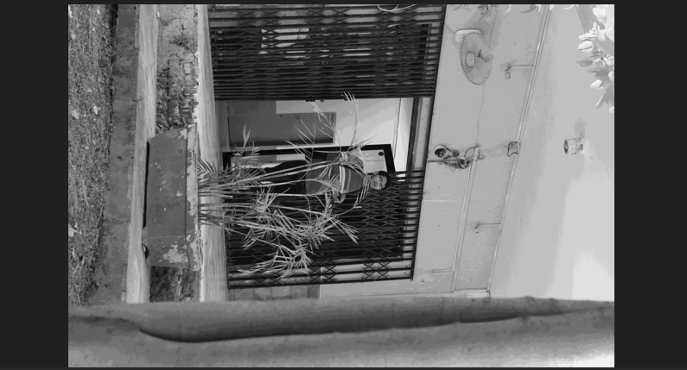

Example 4: QuadTree Division:
import numpy as np

img = np.array([
[1, 1, 1, 1],
[1, 1, 1, 1],
[0, 0, 1, 1],
[0, 0, 1, 1]
])

def is_uniform(block):

return np.all(block == block[0, 0])

print(is_uniform(img))
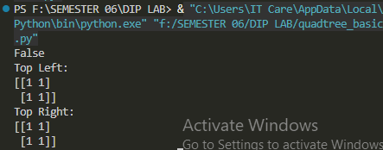

QuadTree GUI Application
import tkinter as tk
from tkinter import filedialog
from PIL import Image
import numpy as np
import matplotlib.pyplot as plt

class QuadTreeGUI:

def __init__(self, root):

self.root = root

tk.Button(root,
text="Load Image",
command=self.load_image).pack()

def load_image(self):

path = filedialog.askopenfilename()

img = Image.open(path).convert('L')

self.image = np.array(img)

plt.imshow(self.image,
cmap='gray')

plt.show()

root = tk.Tk()

app = QuadTreeGUI(root)

root.mainloop()
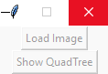

Code:
import numpy as np

img = np.array([
[50, 50, 50, 50],
[50, 50, 50, 50],
[90, 90, 90, 90],
[90, 90, 90, 90]
])

rows, cols = img.shape

compressed = []

for i in range(rows):

start = 0

for j in range(1, cols):

if img[i][j] != img[i][j - 1]:

compressed.append(
(i,
start,
j - 1,
img[i][j - 1])
)

start = j

compressed.append(
(i,
start,
cols - 1,
img[i][cols - 1])
)

print(compressed)
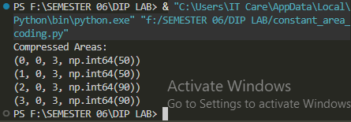

LAB TASK 1

Advanced LZW GUI Application

import tkinter as tk
from tkinter import filedialog, messagebox
from PIL import Image, ImageTk
import numpy as np
import pickle
import matplotlib.pyplot as plt
from collections import Counter

def lzw_compress(data):

dictionary = {bytes([i]): i for i in range(256)}

w = b""

compressed = []

dict_size = 256

for byte in data:

wc = w + bytes([byte])

if wc in dictionary:
w = wc

else:
compressed.append(dictionary[w])

dictionary[wc] = dict_size

dict_size += 1

w = bytes([byte])

if w:
compressed.append(dictionary[w])

return compressed

def lzw_decompress(compressed):

dictionary = {i: bytes([i]) for i in range(256)}

result = bytearray()

w = bytes([compressed[0]])

result += w

dict_size = 256

for k in compressed[1:]:

if k in dictionary:
entry = dictionary[k]

elif k == dict_size:
entry = w + w[:1]

result += entry

dictionary[dict_size] = w + entry[:1]

dict_size += 1

w = entry

return result

class LZWGUI:

def __init__(self, root):

self.root = root

self.root.title("LZW Compressor")

self.canvas = tk.Canvas(root,
width=300,
height=300)

self.canvas.pack()

tk.Button(root,
text="Load Image",
command=self.load_image).pack()

tk.Button(root,
text="Compress",
command=self.compress).pack()

def load_image(self):

path = filedialog.askopenfilename()

self.image = Image.open(path).convert("RGB")

self.image_data = np.array(self.image)

img = self.image.resize((300, 300))

tk_img = ImageTk.PhotoImage(img)

self.canvas.create_image(
0, 0,
anchor=tk.NW,
image=tk_img
)

self.canvas.image = tk_img

def compress(self):

r = self.image_data[:, :, 0].flatten()

compressed = lzw_compress(r)

messagebox.showinfo(
"Compression",
f"Codes: {len(compressed)}"
)

root = tk.Tk()

app = LZWGUI(root)

root.mainloop()
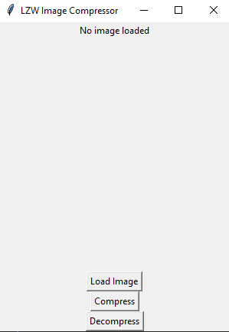

LAB TASK 2:
import tkinter as tk
from tkinter import filedialog
from PIL import Image, ImageTk
import numpy as np
import matplotlib.pyplot as plt

class BitPlaneGUI:

def __init__(self, root):

self.root = root

tk.Button(root,
text="Load Image",
command=self.load_image).pack()

tk.Button(root,
text="Reconstruct",
command=self.reconstruct).pack()

self.canvas = tk.Canvas(root,
width=400,
height=400)

self.canvas.pack()

def load_image(self):

path = filedialog.askopenfilename()

img = Image.open(path).convert('L')

self.image_array = np.array(img)

self.bit_planes = []

for i in range(8):

plane = ((self.image_array >> i) & 1) * 255

self.bit_planes.append(plane)

def reconstruct(self):

reconstructed = np.zeros_like(
self.image_array,
dtype=np.uint8
)

for i in range(8):

reconstructed += (
((self.bit_planes[i] > 0)
.astype(np.uint8)) << i
)

img = Image.fromarray(reconstructed)

img.show()

root = tk.Tk()

app = BitPlaneGUI(root)

root.mainloop()
